VIETNAM INTERNATIONAL UNIVERSITY – HO CHI MINH CITY INTERNATIONAL UNIVERSITY

WEB APPLICATION DEVELOPMENT PROJECT RESTAURANT MANAGEMENT SYSTEM

By

Nguyen Hoang Giang - Student ID: ITITIU21192

Luu Hoang Duc – Student ID: ITITIU21181

Advisor: Dr. Nguyen Van Sinh

A report submitted to the School of Computer Science and Engineering in partial fulfillment of the requirements for the Final Project

in Web Application Development course - 2024

Ho Chi Minh city, Vietnam, 2024

# TABLE OF CONTENTS

1. **INTRODUCTION** **page 3**
2. **REQUIREMENT ANALYSIS AND DESIGN** **page 9**
   1. **Requirement Analysis** **page 9**
   2. **Design** **page 39**
3. **IMPLEMENTATION** **page 58**
   1. **GENERAL PAGES:** **page 58**
      1. **Welcome page** **page 58**
      2. **Log-in page** **page 60**
      3. **Sign-up page** **page 62**
      4. **Retrieve the password** **page 63**
   2. **CUSTOMER ROLE PAGES** **page 64**
      1. **Information pages** **page 64**
      2. **Menu Interfaces** **page 65**
      3. **Ordering Interfaces from customer’s side** **page 67**
   3. **ADMIN ROLE PAGES** **page 87**
      1. **Menu Page** **page 87**
      2. **Dashboard Page** **page 92**
      3. **Food Track Page.** **page 94**
4. **DISCUSSION AND CONCLUSION** **page 114**
5. **REFERENCES** **page 115**

# INTRODUCTION

This section provides an overview of the background of our software development team – DG. It also highlights essential information about our project and concludes with the constraints we encountered during its development.

* 1. **ABOUT US**

DG is a dedicated software development team that focuses on creating innovative software solutions. As part of our team, DG Web Application Solution specializes in developing Web applications. We strive to deliver optimal Web-based solutions in terms of performance, design, and efficiency to meet the diverse needs of our clients. Our target users include small and medium enterprises, public figures, and collaborative software development partners.

* 1. **THE PRODUCT’S INFORMATION**

The system leverages technology to revolutionize the dining experience by minimizing human intervention. Each table is equipped with a touch-screen interface, enabling customers to browse the menu, place orders, and receive estimated preparation times directly from the kitchen.

Once a dish is prepared, it is delivered to the table using an automated system. After the meal, customers can request their bill, complete secure payments via debit card, and leave without interacting with staff.

Managers can easily update the menu, adjust prices, or make changes before service begins. This web-based system enhances convenience, efficiency, and privacy, offering a seamless, technology-driven dining experience.

* 1. **WORK BREAKDOWN STRUCTURE**

The structure of our project can be expressed in the ***Figure 3.1:***

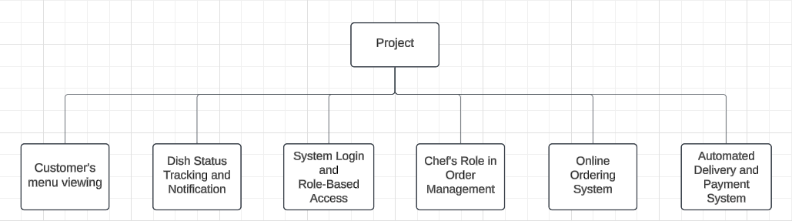

Figure 3.1

In each branch of this tree, we also have subtrees which describes the tasks needed to be accomplished of my team.

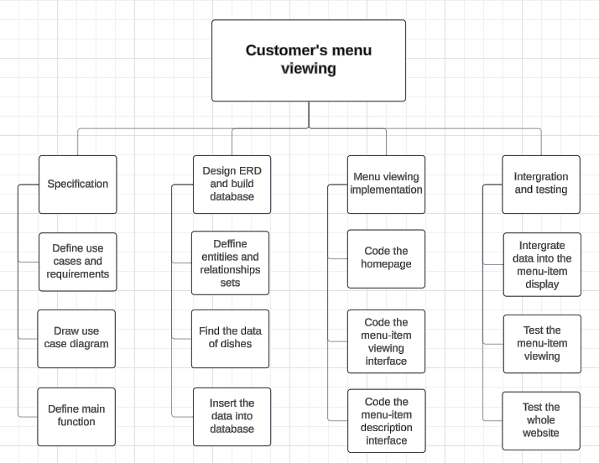The tasks for the Customer’s menu viewing is described in the ***Figure 3.2***:

Figure 3.2

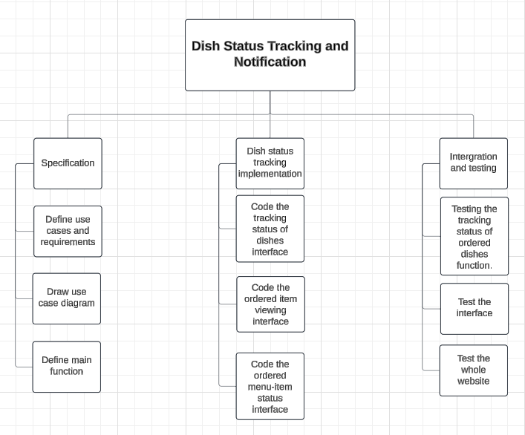The tasks for the Dish Status Tracking and Notifications is described in the ***Figure 3.3***:

Figure 3.3

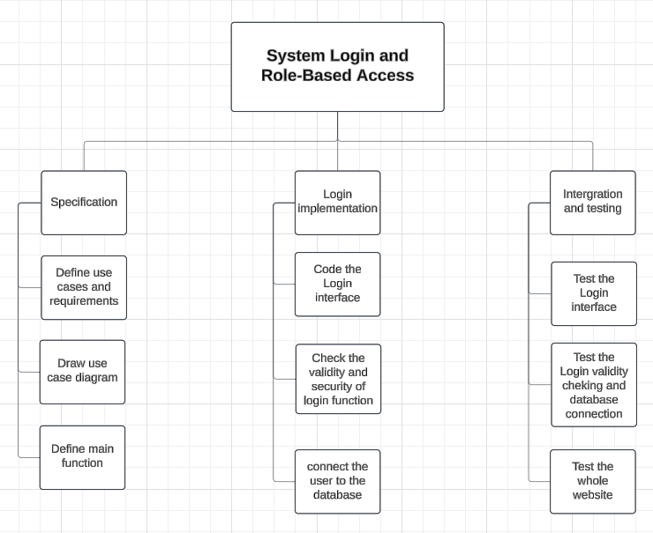The tasks for the System Login is described in the ***Figure 3.4***:

Figure 3.4

The tasks for the Managing Order of Chef’s role is described in the ***Figure 3.5***:

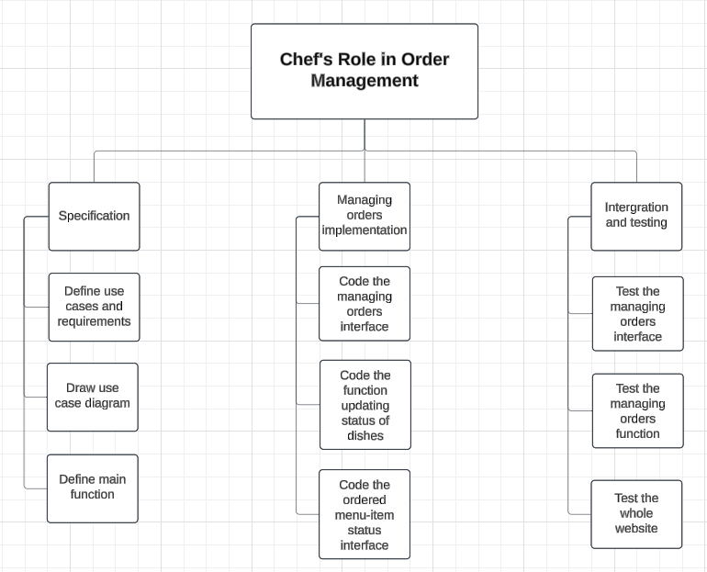

Figure 3.5

The tasks for the Online Ordering System is described in the ***Figure 3.6***:

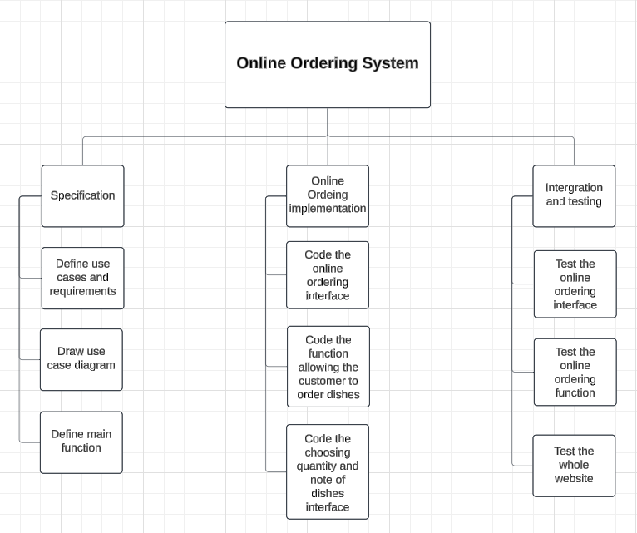

Figure 3.6

The tasks for the Payment System is described in the ***Figure 3.7***:

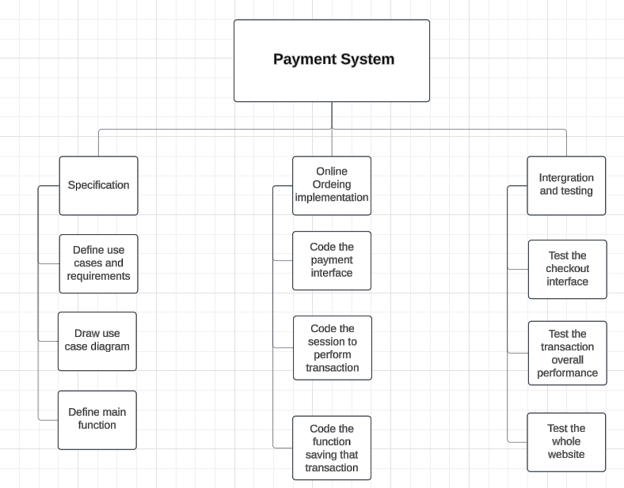

Figure 3.7

These tasks are anticipated to be completed and fully tested after each iteration of the development process, as we are adopting the agile methodology instead of the traditional approach, which separates the steps.

* 1. **DEVELOPMENT PROCESS**

Our team has decided to adopt the agile methodology for our project, specifically using the Scrum framework to guide us toward the successful completion of the project.

We anticipate that our requirements will evolve, and we aim to develop the product incrementally, addressing each functionality requested by the customers.

After every iteration, the product will be enhanced with additional features and a more user-friendly interface, enabling users to interact with the system effectively and meet their needs.

Our method can be described in the ***Figure 4.1***:

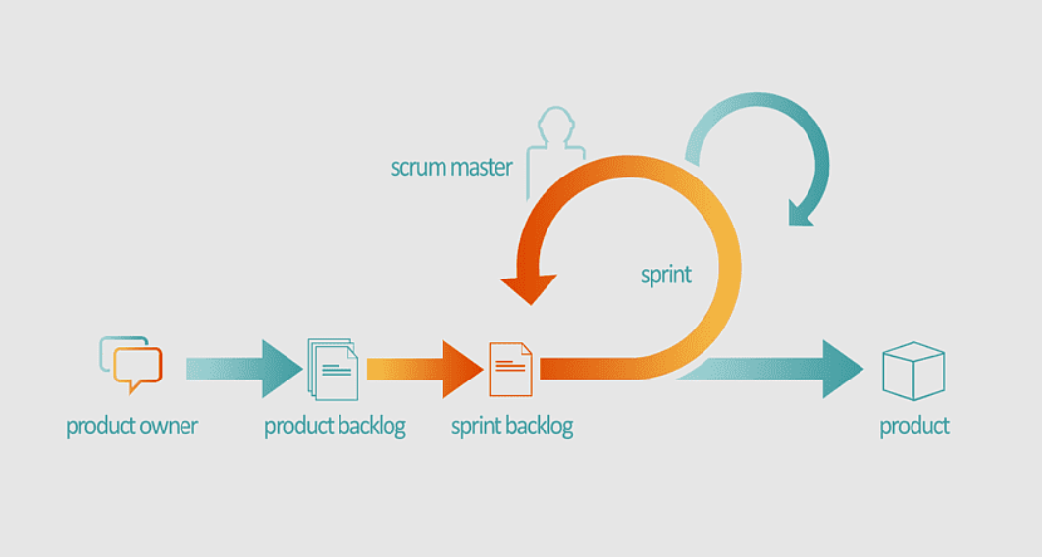

Figure 4.1

* 1. **DEVELOPMENT ENVIRONMENT**

Since this is a web-based product, the project is conducted using some Web Design and Programming Language under the model of MVC.

The following Programming Languages are used within our system:

1. **HTML:** to create an outline of the webpages
2. **CSS:** to design the looks of the webpages
3. **JavaScript:** to create animations for the webpages
4. **ReactJS:** to create form to perform transactions of the customers
5. **NodeJS:** to manipulate the data from the form to create dynamic webpages
6. **MySQL:** to store the database of the system

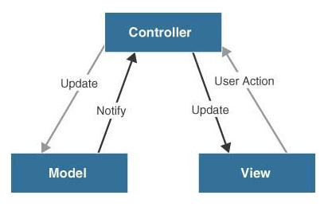The code are implemented according to the MVC model in the ***Figure 5.1***:

Figure 5.1

1. ***Model:*** the data of the system stored in the database and external system.
2. ***View:*** the user interface.
3. ***Control:*** the logic and algorithms used to develop a dynamic website with required functionalities.

In addition, our group leveraged cloud-based tools like Google Docs to streamline collaboration and seamlessly integrate contributions from all team members. We also utilized Microsoft Project, a project management tool, to monitor overall progress and evaluate each member's individual performance.

# REQUIREMENT ANALYSIS AND DESIGN

This section provides a concise overview of the requirement analysis and design process, serving as a foundation for the future implementation of the project. Using this requirements specification as a guide, we will develop each feature while ensuring all specified conditions, along with both functional and non-functional requirements provided by the customers, are met. Throughout the implementation phase, we will continuously review and refine the system to ensure progress is effectively tracked and the project remains aligned with its objectives.

* 1. **REQUIREMENT ANALYSIS**

**USE CASE DIAGRAM**

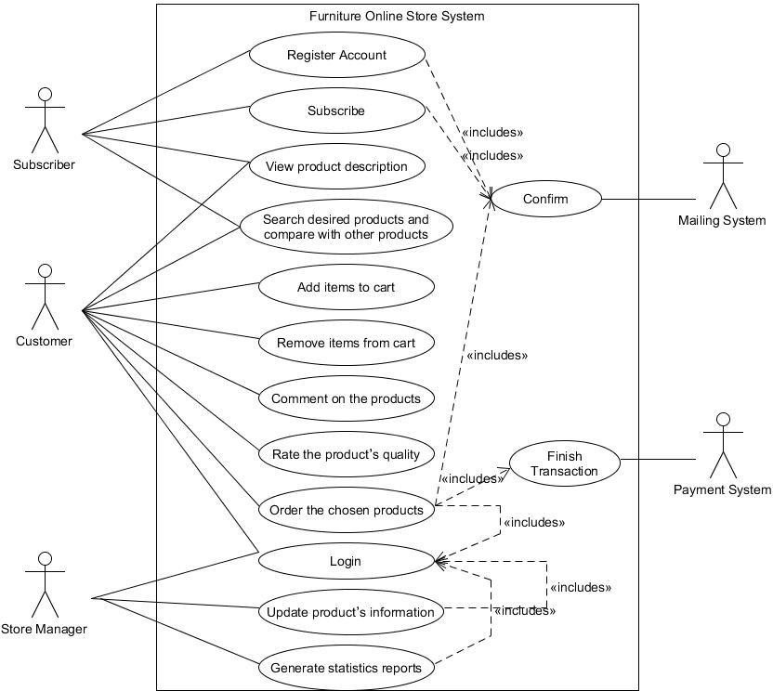

**Use Case 1:**

**Name: Log in the store system Identifier** *UC1*

**Inputs:**

1. User name
2. Password

**Outputs:**

1. The home page with user’s authorization [If success]
2. The login page [If fail]

**Basic Course**

|  |  |
| --- | --- |
| Actor: User (Customer/Store Manager) | System |
| 1. Open the login page | 1.1. Display the login page |
| 2. Enter user name and password |  |
| 3. Submit | * 1. Check the user’s info.   2. If success, return the home page   3. Else return the login page |

**Precondition**

1. User has an registered account of online store that is created earlier (ID and password)

**Post condition**

1. None

**User story:** As an online shop visitor, I want to log in the shop system so that I can use functions of the shop like buy products, gain the promotion, discuss about the products …

**Use Case 2:**

**Name: Rate/Vote the quality of products Identifier** *UC2*

**Input:**

1. Vote value from 1 (worst) to 5 (best) stars by clicking the vote section

**Outputs:**

1. New voting value of product in database
2. Product page with updated voting value

**Basic Course**

|  |  |
| --- | --- |
| Actor: User (Customer/Store Manager) | System |
| 1. Open that product detail page | 1.1. Display the page with details  of product |
| 2. Vote the product by choosing the  number of stars from 1 (worst) to 5 (best) | 2.1. Display user’s selection |
| 3. Submit | * 1. Update the voting value in database.   2. Reload the page to show the   updated voting value from user |

**Preconditions**

1. User must log in the store system earlier
2. User opens the product page with the details of a certain product

**Post condition**

1. None

**User Story:**

As a shop customer, I want to vote or rate the product to recommend other customers to buy that products

**Use Case 3:**

**Name: Comment and Discussion about the products Identifier** *UC3*

**Input:**

1. Comment of user in form of text

**Outputs:**

1. Updated comment storage in database
2. Reloaded product page that show the posted comment from user

**Basic Course**

|  |  |
| --- | --- |
| Actor: User (Customer/Store Manager) | System |
| 1. Open that product detail page | 1.1. Display the page with details  of product |
| 2. Click on “Reply” button | 2.1. Display the text area to get  input from user |
| 3. Typing the comment in the text  area |  |
| 4. Submit | * 1. Insert the comment instance with content input from user into database   2. Reload the page to show the posted comment that user has just posted |

**Precondition**

1. User must log in the store system earlier

**Post condition**

1. None

**User Story:**

As a shop customer, I want to discuss about the products to gain more detailed information from the shop manager as well as other customers

**Use Case 4:**

**Name: Search the product by name, price, category, functionalities Identifier** *UC4*

**Inputs:**

1. Searching keywords
2. Category where keyword will be searched

**Output:**

1. The result page with products related to the searching keyword

**Basic Course**

|  |  |
| --- | --- |
| Actor: User (Customer/Store Manager) | System |
| 1. Access a page of online shop | 1.1. Display the page |
| 2. Click on the text area of search  section |  |
| 3. Input the keyword used to search the  product |  |
| 4. Select the searching section  (name/price/category/functionalities) | 4.1. Display the selected section |
| 5. Submit | * 1. Sort out the products matching with the search condition from database   2. Load a result page and display the search result. |

**Precondition**

1. None

**Post condition**

1. None

**User story:**

As a shop visitor, I want to search the product with search engine so that I can find out the appropriate product conveniently

**Use Case 5:**

**Name: Register a new account of online store Identifier** *UC5*

**Input:**

1. Personal information from user

**Outputs:**

1. The home page [If success]
2. The register page [If fail]

**Basic Course**

|  |  |
| --- | --- |
| Actor: User (Customer/Store Manager) | System |
| 1. Access a page of online shop | 1.1. Display the page |
| 2. Click on the “register” button | 2.1. Display the register page |
| 3. Input the personal information  (ID, password, Full name, DOB, email…) |  |
| 4. Submit | * 1. Check the validity of account information   2. If success, display the page that remind user check the mailbox   3. If fail, return back to the   register page |

**Preconditions**

1. None

**Post condition**

1. None

**User story:**

As a visitor, I want to have a shop account so that I can take advantage of the offered function from the online shop

**Use Case 6:**

**Name: Add/Remove desired products to/from wish list and shopping cart Identifier** *UC6*

**Input:**

1. None

**Output:**

1. Display message that user has successfully added items to shopping cart or wish list

**Basic Course**

|  |  |
| --- | --- |
| **Actor: member** | **System** |
| 1. Click the “Add to Cart” button | * 1. If logged in, add items to member’s shopping cart   2. Else display “Must log in” message |
| 2. Click the “Add to Wish List” button | * 1. If logged in, add items to member’s wish list   2. Else display “Must log in” message |
| 3. Click the “My Shopping Cart” image | * 1. Open the “Your Shopping Cart” page   2. If logged in, display all the products added   3. Else display “Must log in” message |
| 4. Click “Remove from Cart” of item | 4.1. Remove item from Shopping Cart |
| 5. Input new quantity for the selected  item | 5.1. Update the quantity for the selected item in  the shopping cart |
| 6. Click the “My Wish List” image | * 1. Open the “Your Wish List” page   2. If logged in, display all the products added   3. Else display “Must log in” message |
| 7. Click “Remove item” in wish list | 7.1. Remove item from Wish List |
| 8. Click the “Add to Cart” button in wish list | 8.1. Add items to member’s shopping cart |

**Preconditions**

1. User has logged in
2. User is currently in the product viewing or product description page

**Post conditions**

1. Items added to or removed from the shopping cart or wish list
2. Database updated

**User story 1:**

As a user, I want to add the selected item to cart so that I can check them out later with the quantity I want.

**User story 2:**

As a user, I want to remove the item from my shopping cart so that I can choose others which suit me better.

**User story 3:**

As a user, I want to alter the quantity of the item so that I can buy just enough what I need

**User story 4:**

As a user, I want to add item into my wish list so that I can save them for future references.

**User story 5:**

As a user, I want to remove some item from my wish list so that I can buy them now or I can add new items which appeals me more.

**User story 6:**

As a user, I want to add the product into my wish list to my shopping cart so that I can check out the items I need.

**Use Case 7:**

**Name: Perform buying transaction and checkout Identifier** *UC7*

**Input:** None

**Output:** Display message that user has successfully purchased products

**Basic Course**

|  |  |
| --- | --- |
| **Actor: member** | **System** |
| 1. Click Checkout button | * 1. Ask user to log in   2. Navigate to Checkout page   3. Create a session   4. Display the user’s shopping cart |
| 2. Click Next | 2.1. Display the form for user to input their  information, type of payment for the current transaction |
| 3. Fill out the form and click Submit | * 1. Display message about successful transaction   2. Update the database   3. Destroy the current session   4. Navigate back to homepage |
| 4. Click Update shopping cart | * 1. Destroy the current session   2. Navigate to Shopping cart page |

**Preconditions**

1. Shopping cart is not empty
2. User has register an account

**Post conditions**

1. Mail confirmation is successfully sent
2. Database updated

**User story 1:**

As a user, I want to check out the products in my shopping cart so that I can buy them online and get them shipped to my place.

**User story 2:**

As a user, I want to update my shopping cart so that I can add more items or remove the items that I find not so much necessary for now.

**Use Case 8:**

**Name: Get the purchase receipt via email Identifier** *UC8*

**Input:**

1. User’s email

**Output:**

1. Display message that email has been successfully sent

**Basic Course**

|  |  |
| --- | --- |
| **Actor: member** | **System** |
| 1. Click Done button | * 1. Take the user’s all information and combine in one PDF file   2. Attach this file and send an email to the provided email   3. Display message that email has been sent |

**Preconditions**

1. The buying transaction must be completed
2. User’s email must be provided

**Post conditions**

1. Email must have all information of the user
2. Ensure the email Sent to the correct destination

**User story:**

As a user, I want to receive a receipt via email after I have purchased from your store so that I can confirm what I have ordered and be acknowledged when the stuff will be shipped.

**Use Case 9:**

**Name: View user’s profile Identifier** *UC9*

**Input:**

1. None

**Output:**

1. Display the user’s profile

**Basic Course**

|  |  |
| --- | --- |
| **Actor: member** | **System** |
| 1. Click My Profile button | * 1. If logged in, navigate to the User’s Account page   2. Else ask the user to log in   3. If logged in, display the user’s information as well as previous purchases and discounts |

**Preconditions**

1. The user has registered an account
2. The user has logged in

**Post condition**

* 1. Display all information of the user

**User story:**

As a user, I want to view my profile so that I can change my personal information and view the discount I am offered by the store for being a loyal customer.

**Use Case 10:**

**Name: Update the product information and clearance sale-off Identifier**: UC10

**Inputs**:

* + 1. Product’s Updated Information
    2. Sale-off event’s Description (option)

**Output**:

1. Display result on the store’s page

**Basic Course:**

|  |  |
| --- | --- |
| Actor: Store Manager | System |
| 1. Login as store manager | 1.1 System will resolve this step base on UC1 |
| 2. Request for store’s database | 2.1 System will display the store’s database to the user on screen |
| 3. Update the product’s information | * 1. If nothing wrong occurs, update the information.   2. Else, notify the user of the error. |
| 4. Create an sale events by picking out the items and update the new price for those particular items | * 1. If nothing wrong occurs, update the price for the item.   2. Else, notify the user of the error. |
| 5. Input for sale’s event description | * 1. Display form for the user to input description text   2. Will show the event on the store’s homepage |
| 6. Submit the form | 6.1 Update the database with input information |

**Precondition**

1. The user has logged in as store manager

**Post condition**

1. Display all information of the user

**User Stories**: Store manager (user) wants to update the quantity of certain items because the store have just received the supplies from the suppliers. Store manager also want to create a sale event on some particular items so that they have to reduce the current price of those items. Store

manager also create the description for sale event.

**Use Case 11:**

**Name: Generate reports of sales after each day/month/quarter/year and customers’ interests Identifier**: UC11

**Input:**

1. Period of time of the sale

**Output**:

1. Reports of sale containing all products sale information during input period

**Basic Course:**

|  |  |
| --- | --- |
| Actor: Store Manager | System |
| 1. Login as store manager | 1.1 System response similar as UC1 |
| 2. Request to generate report of sales for months/quarter/year | * 1. Summarize and produce report   2. Display on screen   3. Print out report |

**Pre-condition*:***

1. Valid period of time input

**Post-condition*:*** None

**User Stories**: As a store manager, I want to generate the report of sale of the store for months/quarters/year to generalize how well the business is doing as well as other important business factors to determine the store’s activities.

**Use Case 12:**

**Name: View the product’s information on the web page**

**Identifier**: UC12

**Input**:

* 1. Click on the product after searching

**Outputs**:

1. Display the more detailed version of the product (description, in stock or out of stock, etc.)
2. Photos of the products taken from different perspectives
3. Rates and comments from different users

**Basic course**

|  |  |
| --- | --- |
| **Actor: Visitor** | **System** |
| **1. Click on the searched product** | **1.1 Display the product description in more details** |
| **2. View the comments in more details** | **2.1 Expand the comments’ pages and lists** |

**Pre-condition*:*** Visitors searched the product and got the desire result.

**Post-condition*:*** None

**User Stories*:*** As a visitor, I want to see the product in more details along with comments and ratings to determine if the product is of high quality, no fake, from prestigious brand or got any errors during the progress of production.

1. **FUNCTIONAL REQUIREMENTS**

## Use Case 1: Log in the store system

* 1. ***The Scope of the Work***
     + This occurs in the sprint 5 in the process
     + 4 tasks needed for this function
     + 20 hours of effort is needed for this function
  2. ***The Scope of the Product***: This is the main part of user’s login functionality

## Functional and Data Requirements

1. *Functional Requirement*

_ Shall display the log in so that user can input the information of account

_ Shall achieve the information of the account that is matched with the ID that user logs in from the database

_ Shall decrypt password of user account from the database

_ Shall check the validity of user login account

1. *Data Requirement*: The log in information (ID and password) must be valid

## Use Case 2: Create a new store account

1. ***The Scope of the Work***
   * This occurs in the sprint 6 in the process
   * 5 tasks needed for this function
   * 20 hours of effort is needed for this function
2. ***The Scope of the Product***: This is the a part of user’s login functionality

## Functional and Data Requirements

1. *Functional Requirement*

_ Shall display the page to require account information from the user

_ Shall check the validity of account ID

_ Shall insert a new account of user into database

_ Shall link information to mailing system

_ Shall display the announcing page the success of registration process.

1. *Data Requirement*

_ Valid account information (ID is not used, email is valid)

## Use Case 3: Comment and Discuss about the products

1. ***The Scope of the Work***
   * This occurs in the sprint … in the process
   * 4 tasks needed for this function
   * 20 hours of effort is needed for this function
2. ***The Scope of the Product***: This is a part that offers function that is discussion and comment on the product

## Functional and Data Requirements

1. *Functional Requirement*

_ Shall check the user authorization

_ Shall display the comment box

_ Shall insert the comment into database

_ Shall display the comment on the discussion section

1. *Data Requirement****:*** None

## Use Case 4: Rate/Vote the quality of products

1. ***The Scope of the Work***
   * This occurs in the sprint … in the process
   * 5 tasks needed for this function
   * 20 hours of effort is needed for this function

## The Scope of the Product

This is a part that offers function that is Voting/Rating on the product

## Functional and Data Requirements

1. *Functional Requirement*

_ Shall retrieve and Display current voting value from the database

_ Shall check the authorization of the user

_ Shall check the voting ability of user

_ Shall display the voting section for user

_ Shall update/Insert the voting value of product inside database

1. *Data Requirement*

_ Each user has only one chance to vote the product

## Use Case 5: Search the product by name, price, category, functionalities

1. ***The Scope of the Work***
   * This occurs in the sprint 4 in the process
   * 3 tasks needed for this function
   * 20 hours of effort is needed for this function

## The Scope of the Product

_ This is a part that offers function that is Searching the product base on name/price/category/functionalities

## Functional and Data Requirements

1. *Functional Requirement*

_ Shall display search section

_ Shall sort out the match products from the database

_ Shall display the search result

1. *Data Requirement****:*** None

## Use Case 6: Add/ Remove desired products to/from wish list and shopping cart

1. ***The Scope of the Work***
   * This occurs in the sprint 6 in the process
   * 4 tasks needed for this function
   * 20 hours of effort is needed for this function
2. ***The Scope of the Product***: This is a part in the last piece of the product

## Functional and Data Requirements

* + *Functional Requirements****:***
* Shall add item to cart
* Shall add item to wish list
* Shall remove item from cart
* Shall remove item from wishlist
* Shall update the ***wishlist*** table in the database
  + *Data Requirements****:***
* The total value of the purchase = quantity * price per item

## Use Case 7: Perform buying transaction and checkout

1. ***The Scope of the Work***
   * This occurs in the sprint 6 in the process
   * 5 tasks needed for this function
   * 30 hours of effort is needed for this function
2. ***The Scope of the Product***: This is a part in the last piece of the product

## Functional and Data Requirements

* + *Functional Requirements****:***
    - Shall destroy a session
    - Shall view/update shopping cart
    - Shall display input form to ask for user’s information
    - Shall the user’s information
    - Shall update the ***orders*** table in the database
    - Shall update the point in the ***member*** table in the database
  + *Data Requirements****:*** none

## Use case 8: Get the purchase receipt via email

1. ***The Scope of the Work***
   * This occurs in the sprint 6 in the process
   * 4 tasks needed for this function
   * 10 hours of effort is needed for this function
2. ***The Scope of the Product***: This is a part of the last piece of the product

## Functional and Data Requirements

* + *Functional Requirements****:***
    - Shall record the user’s information
    - Shall combine all information in a PDF file as a receipt
    - Shall send a confirmation email to the customer with receipt attached
    - Shall display successful sent message
  + *Data Requirements****:***
    - User’s email must be provided and valid

## Use Case 9: Display user’s profile

1. ***The Scope of the Work***
   * This occurs in the sprint 5 in the process
   * 3 tasks needed for this function
   * 30 hours of effort is needed for this function
2. ***The Scope of the Product***: This is a part of the user’s login functionality

## Functional and Data Requirements

* + *Functional Requirements****:***
    - Shall display user’s personal information
    - Shall display user’s previous purchases
    - Shall display user’s discount via points
  + *Data Requirements****:***
    - User’s point is derived from the number and value of previous orders

***Use Case 10: Check availability of merchandise, Update the product information and clearance sale-off***

1. **Scope of the work**:
   1. This occurs in the sprint 5 in the process
   2. 3 tasks needed for this function
   3. 30 hours of effort is needed for this function
2. **Scope of the Product:** part of the Store Manager Management use cases
3. **Functional and Data requirements:**

* *Functional Requirements:*
  + Shall update the product information
  + Shall insert into the database the clearance price sale-off
* *Data Requirements:*
  + The data in the ***product*** table exists before query

***Use Case 11: Generate reports of sales after each day/month/quarter/year and customers’ interests***

1. **Scope of the work**:
2. This occurs in the sprint 5 in the process
3. 3 tasks needed for this function
4. 30 hours of effort is needed for this function
5. **Scope of the Product:** part of the Store Manager Management use cases
6. **Functional and Data requirements:**
   * *Functional Requirements:*
     + Shall display the report containing all of the sales in a particular period
     + Shall save the report in PDF
     + Shall suggest the Best Seller Products
   * *Data Requirements:*
     + The data in the ***orders*** table exists before query

## Use Case 12: View the product’s information on the web page (for visitor)

1. ***Scope of the work:***

_ This occurs in the sprint 4 in the process

_ 4 tasks needed for this function

_ 10 hours of effort is needed for this function

## Scope of the Product

_ This is the part of 85 % GUI of the product (how the product might display) and 15% of database retrieval (stock left, numbers of rates, comments,...)

## Functional and Data Requirements:

* 1. ***Functional Requirements:***

+ Shall show images gallery slideshow of the product. (include zoom in, zoom out, forward and backward buttons)

+ Shall rating: Scale from Poor to Excellent (red to green), along with the diagram and favorites.

+ Shall show comment section: Hide and show comments with button, the content should be retrieved from the stored database.

## Data requirement:

+ Sample images

+ Description, stock availability, discount, number of rates, comments’ contents: Taken from the database

1. **NON-FUNCTIONAL REQUIREMENTS**

## Operational requirements:

* + - Must make sure all of the components of the software operate in good manner
    - Must keep the host running licensed so that it can handle all of the requests properly
    - Must keep an administrator to frequently update the software as well as checking for the system’s errors

## Legal requirements:

* + - Must cite all the components integrated into the system to avoid copyright violation
    - Must keep the own-written source code confidential to avoid unauthorized use

## Usability requirements:

* + - Usability is the ease with which a user can learn to operate, prepare inputs for, and interpret outputs of system or component
    - Well-structured user manuals
    - Informative error messages – Error messages must state clear and might include hint to retrieve the solutions.
    - Help facilities.
    - Well-formed graphical user interfaces – easy to learn and navigate.
    - Efficiency of use: goals are easy to accomplish and with few or no user error.

## Humanity Requirements:

* + - The user who works on the system usually has none or little computer background.

Development team must create detail documentation so that the user can easily understand the system just by reading that documentation. The graphical user

interfaces of the system must also be well designed so that it is easy to learn and easy to use. User should not be required a lot of time to learn how to get used to the system interfaces. Also the attractiveness and responsiveness also part of the interface

requirement to help increase user experience.

## Performance Requirements:

This is the concern on speed of the system in operating

1. ***Response Requirements*** (how quickly the system response to the user’s request)
   1. Login response time for both customer and manager must be fast.
   2. Time for the system to update on Database modifications must be small. System must be able to change the multiple database tables’ attributes seamlessly.
   3. Time to process certain services that are offered by the system must be achieved quickly and no delay. Our system must be able to process 10 different

transactions simultaneously.

* 1. Website loading time must be fast and all the items must be generated correctly. For this particular requirement, our system can able to achieve of loading more than 50 products per page in the minimal time.

1. ***Throughput Requirements*** (how much can system achieved in a specific amount of time)
   1. System must able to handle significant large amount of requests from many customers at one time without being delay. Our system must be able to handle more than 1000 visitors simultaneously who are simply browsing our products on the store page.
   2. System must able to handle multiple database modifications quickly.
2. ***Availability Requirements*** (is the system available when is requested by the user)
   1. System should have good memory management – Programming Language garbage collection must be utilized.

## Description:

This is an e-commerce store which might have more than thousands of visitors each day. This will be an extreme heavy workload for the server if all the requests have not been

handled thoroughly. The shopping-cart system must be able to process orders simultaneously as many as possible without getting delay or overload. The website can handle many different requests from many customers on different operating system without being postponed.

## Maintainability Requirements:

Online Store system is a system that needs to update or change continuously. The user of the system has a very little background about inside aspects of the system. Therefore the

developer team has to implement the system in the way that the user and further maintenance team can easily manipulate the current system.

* + - Offer the functions that help user to update/manage the information of products and customers
    - Write well-defined and clean source code with necessary comment lines to enhance the comprehension
    - Design the clear and stable database that is convenient for the further maintenance work

## Support Requirements

System users (especially, Store manager) are the people who do not have much background on technology maintenance. therefore, beside developing the system, the developer team should have a better way so that the user can receive the support from the developer team as soon as possible

* + - Provide the hotline to receive the feedback from store manager if there is a problem
    - Provide a remote maintenance tool (like TeamViewer, Computer Remote control … ) to support the store manager directly
    - Check frequently and maintain the stability of the system (monthly or each 2/3 months)

## Security requirements:

* + - This web operating system shall ensure that data is protected from unauthorized access.
    - Ensure the integrity of the system from accidental or malicious damage.
    - Restrict log-in attempts: Failure to log in the website (five times or more) should lead to a ban from access the website within 24 hours.
    - The access permissions for system data changes might only be done by the administrator. ‹
    - All modification events shall be logged. The event log shall contain "date, "time, "user, "action, "object”, "prior” , " value”, "new value” ,...
    - All communications between the system’s data server and clients must be encrypted (SSL, SSH protocol for HTTP, etc.)
    - When customer logins, a session and timeout should be set.
    - Information of the customers must be encrypted before adding to the database.
    - All system data, including the information of products, customers (cookies, sessions), etc. must be backed up every 24 hours and there should be one copies stored in a

secure location different from where the system is placed.

* + - Policy of privacy should be given out to restrict the third retrieval of many of customers’ information.

## Interface requirements:

* + - Describe all of the technical requirements that affect interfaces such as protocol management, scheduling, directory services, broadcasts, message types, error and buffer management, security, etc. Assign a unique ID number to each requirement.
    - Some non-functional requirements of interface:

+Buttons should include feature symbols equivalent to their functionalities .

+ Sales report included in every successful transaction.

+ Java might support different libraries of Look and Feel to decorate the website.

+ Include language options for native and foreign visitors/customers

* 1. **DESIGN**

System Architecture Model

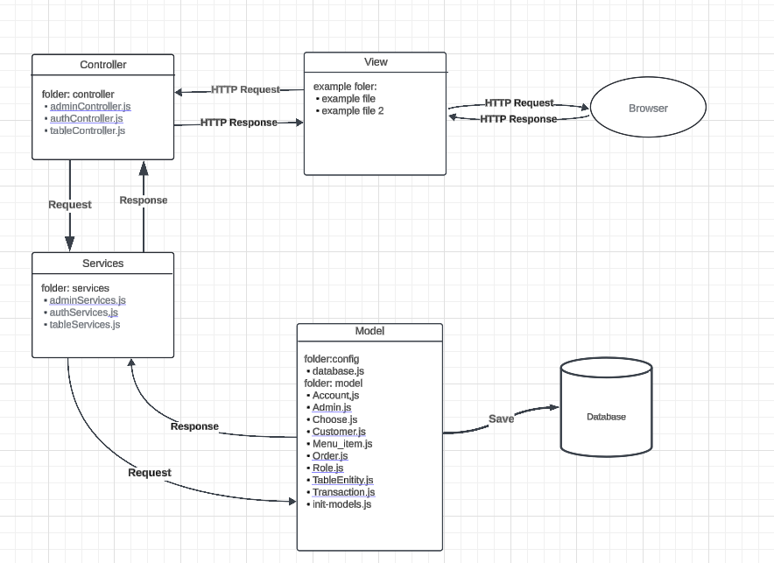

**Entity-Relationship Diagram (ERD)**

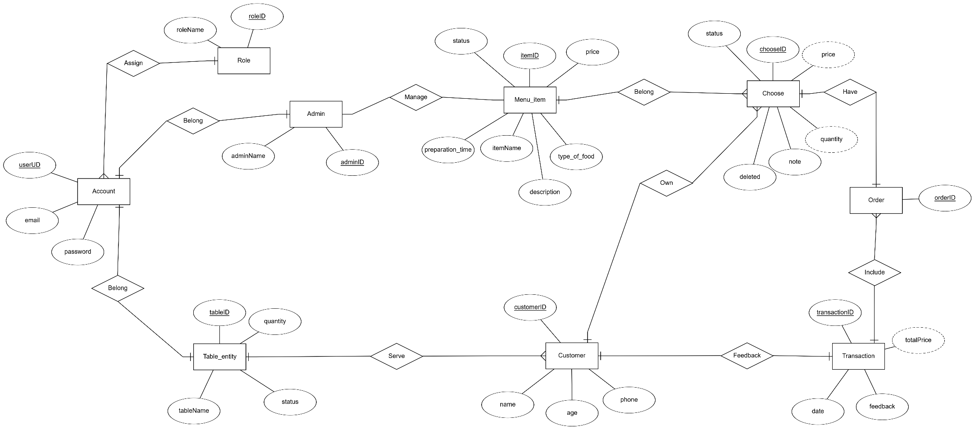

**Schema Diagram**

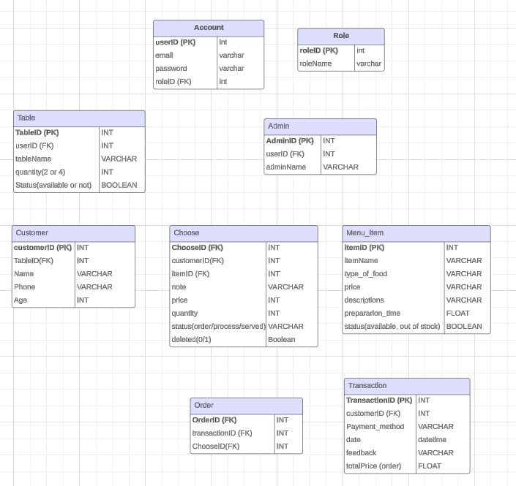

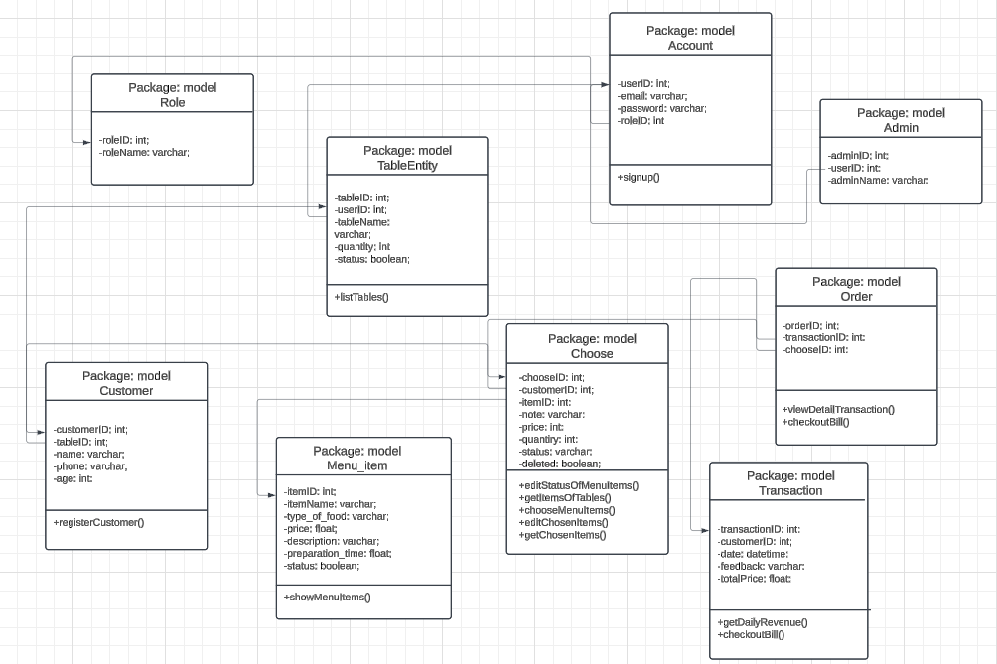**Class Diagram**

**Use Case Diagram**



**Use Case 1: Log in the store system**

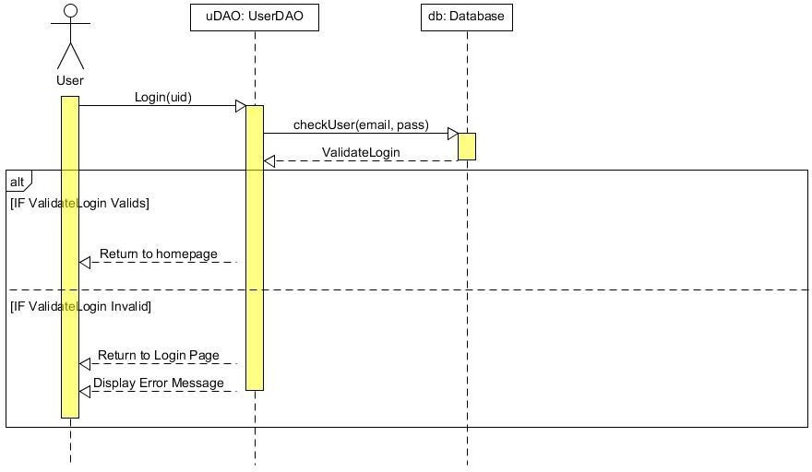

**Use Case 2: Create a new store account**

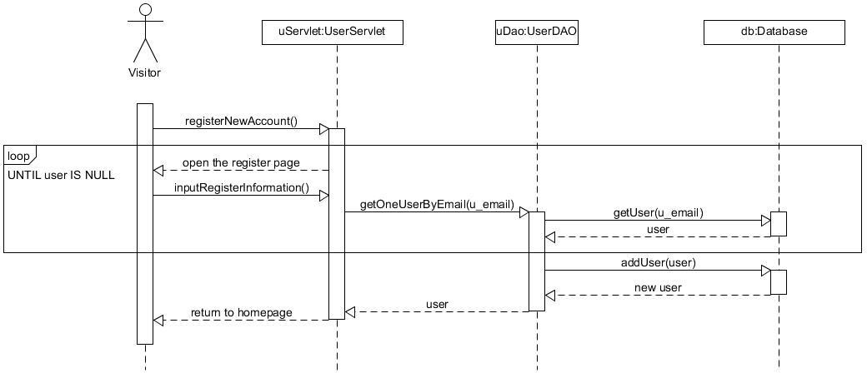

**Use Case 3: Comment and Discussion about the products**

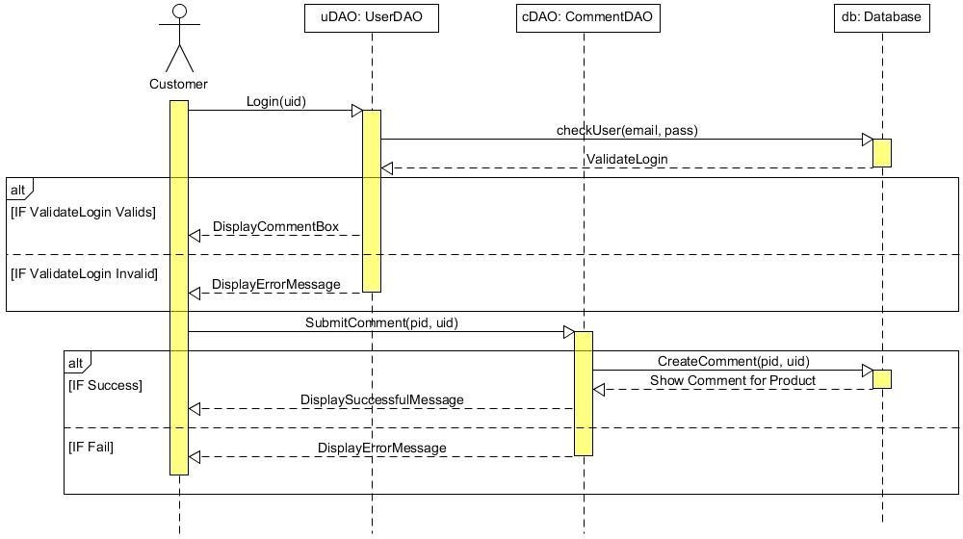

**Use Case 4: Rate/Vote the quality of products**

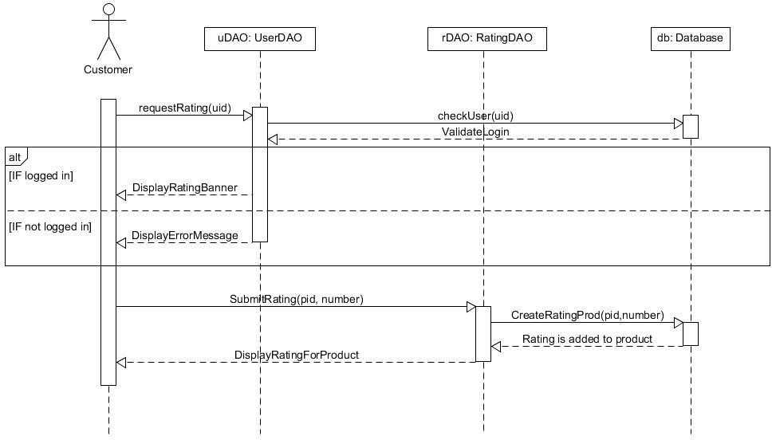

**Use Case 5: Search the product by name, price, category, functionalities**

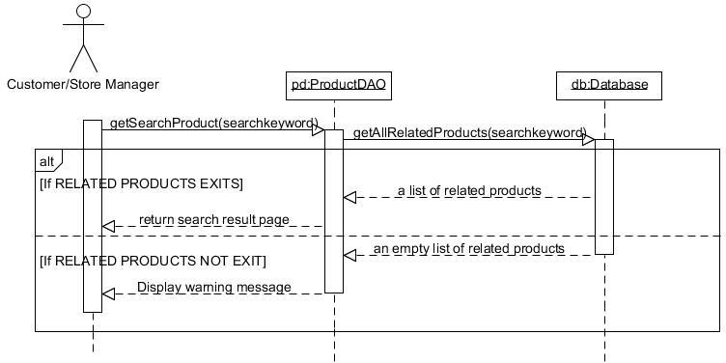

**Use Case 6: Add/ Remove desired products to/from wish list and shopping cart**

***Use Case 6.1: Add to wish list***

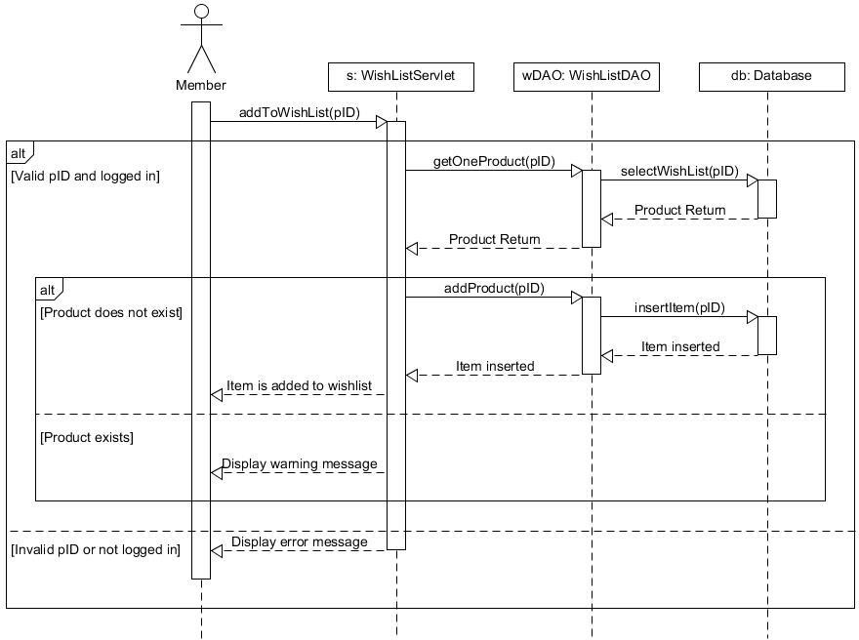

***Use Case 6.2: Remove from wish list***

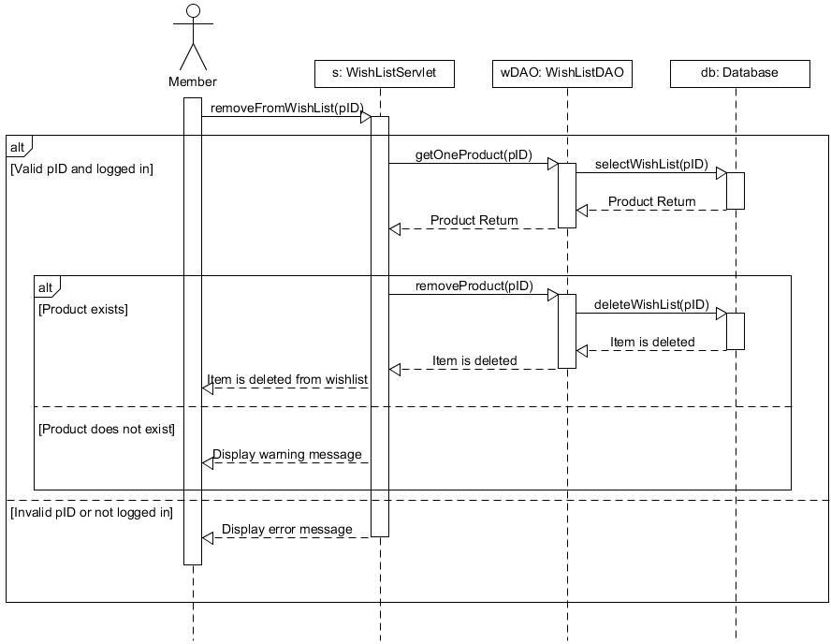

***Use Case 6.3: Add to shopping cart***

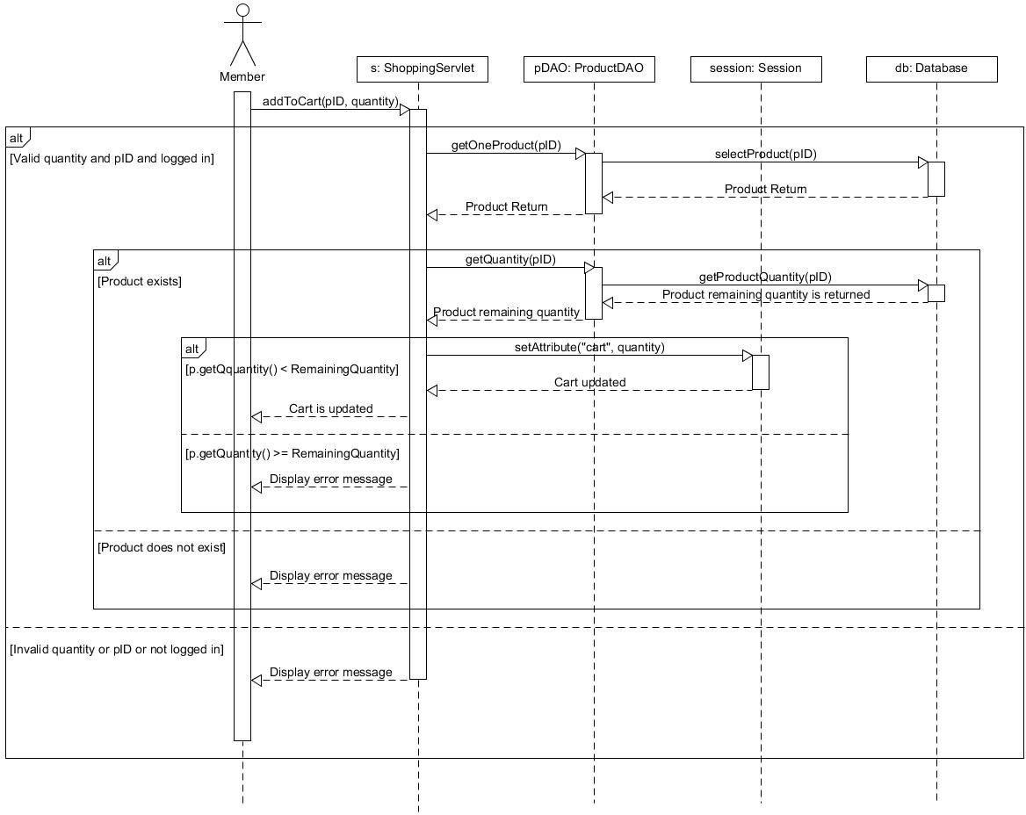

***Use Case 6.4: Remove from shopping cart***

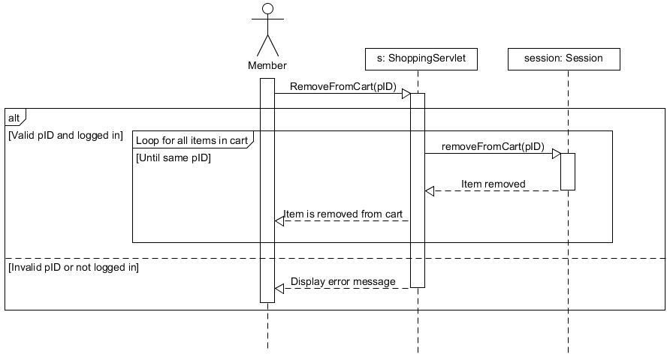

**Use Case 7: Perform buying transaction and checkout**

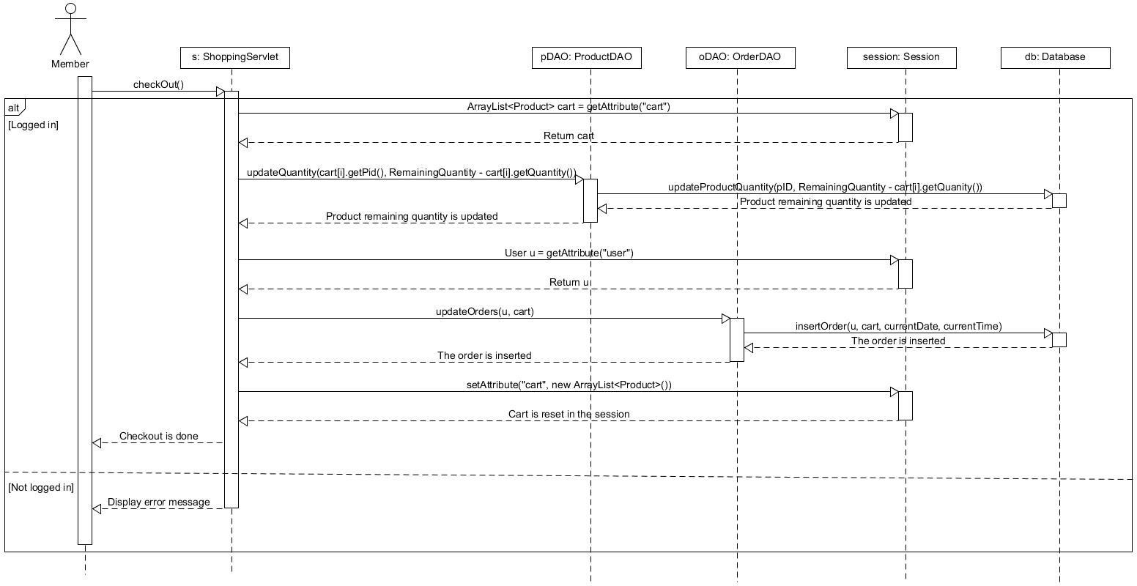

**Use case 8: Get the purchase receipt via email**

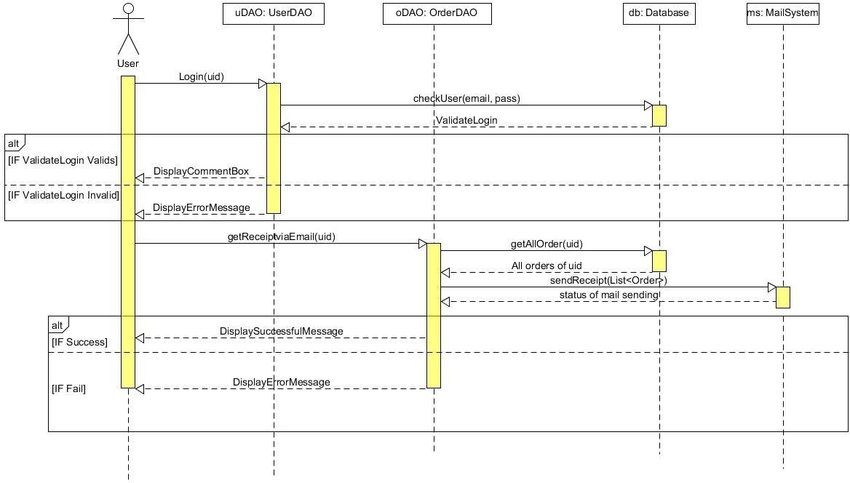

**Use Case 9: Display user’s profile**

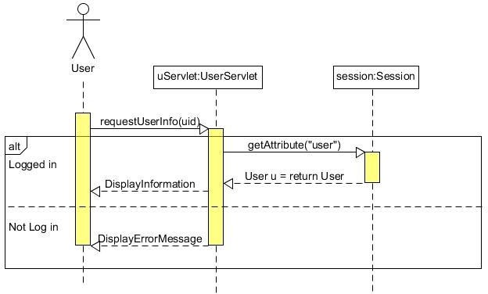

**Use Case 10: Check availability of merchandise, Update the product information and clearance sale-off**

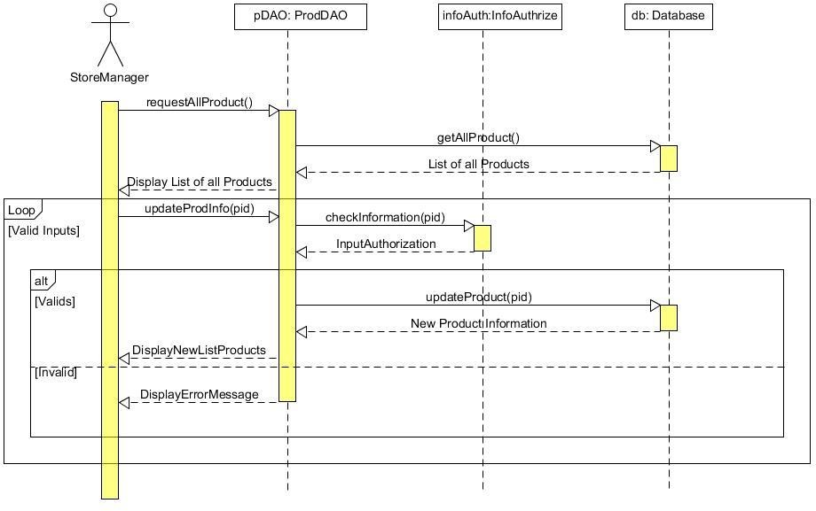

**Use Case 11: Generate reports of sales after each day/month/quarter/year and customers’ interests**

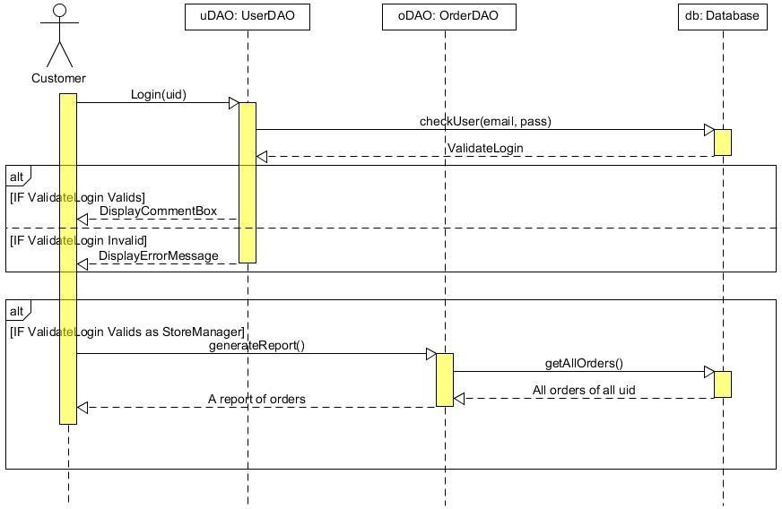

**Use Case 12: View the product’s information on the web page (for visitor)**

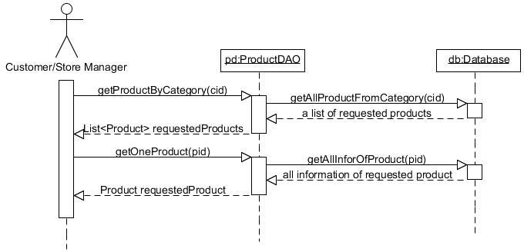

# IMPLEMENTATION

* 1. **GENERAL PAGES:**
     1. **Welcome page:**

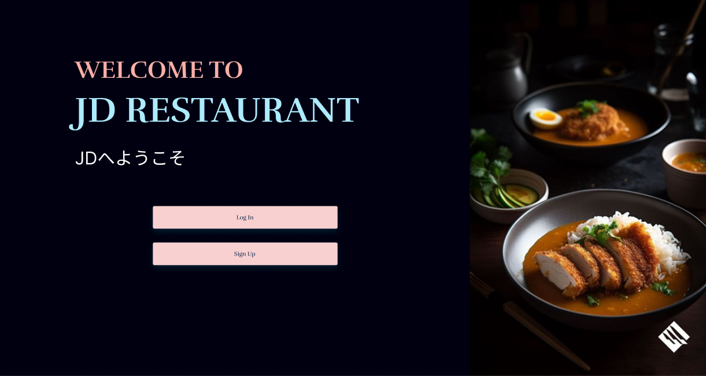

The welcome page serves as the initial interface that users encounter upon accessing the website. This page acts as a gateway, providing users with navigation options to proceed to either the login or sign-up pages. It is designed to accommodate both roles—admin and customer—ensuring a unified entry point for all users. The layout and design of the welcome page prioritize simplicity and clarity, facilitating a seamless transition to authentication processes for both roles.

* + 1. **Log-in page:**

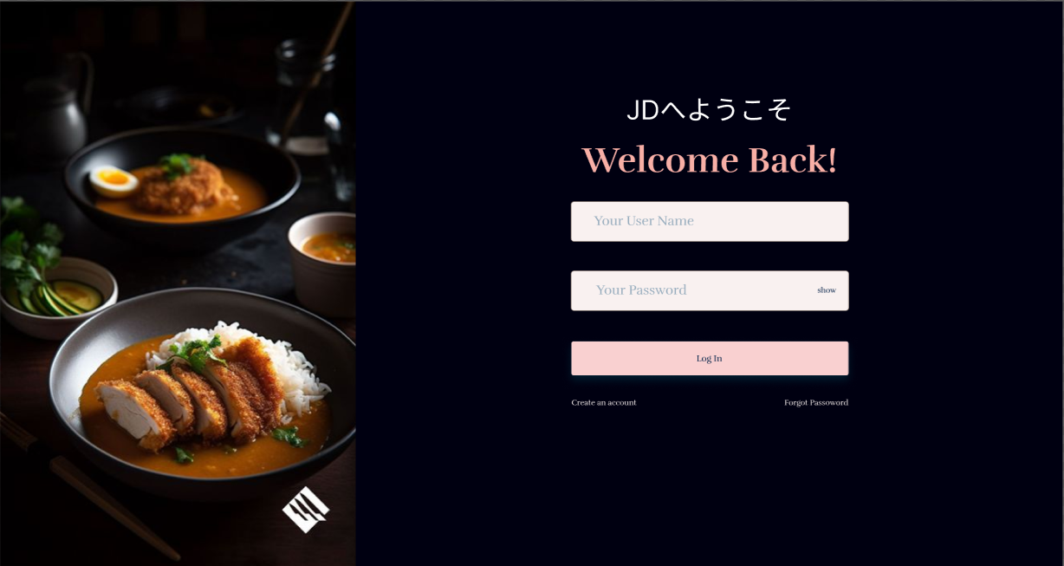

The login page enables users to authenticate their accounts by providing their email and password.

The process is implemented as follows:

1. Input Fields:
   * Users are required to enter their registered email address and password into the respective input fields.
2. Authentication Process:
   * Upon submission, the system retrieves the stored hashed password associated with the provided email address from the database.
3. Password Verification:
   * The system uses the bcrypt.compare() function to securely compare the plaintext password entered by the user with the hashed password stored in the database.
   * The bcrypt.compare() function evaluates the match and returns a boolean value:
     + True indicates the passwords match, and the user is authenticated.
     + False indicates the passwords do not match, and the login is denied.
4. Successful Authentication:
   * If the credentials are valid, the user is granted access to other pages based on their role (Customer or Admin/Chef).
5. Error Handling:
   * If authentication fails (e.g., incorrect email or password), an appropriate error message is displayed to the user, prompting them to re-enter valid credentials.
     1. **Sign-up page:**

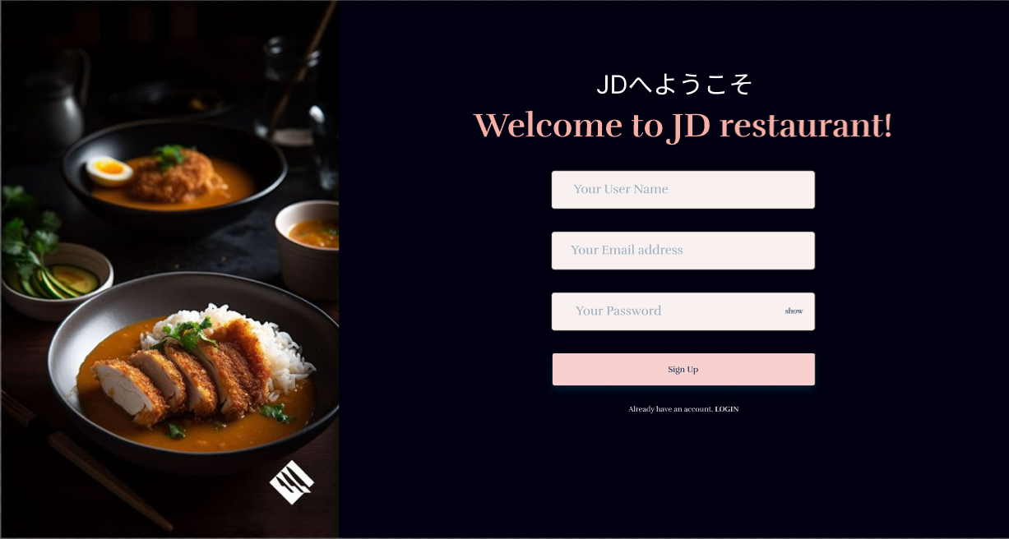

The sign-up page allows users to create a new account in the system.

The process for user registration is outlined as follows:

1. Input Fields:
   * The user is required to provide a username, email address, and password through the designated input fields on the sign-up form.
2. Password Hashing:
   * To enhance security, the provided plaintext password is processed using the bcrypt.hash() function before being stored in the database.
   * The bcrypt.hash() function operates as follows:
     + It takes the plaintext password and a salt factor (a value that increases the complexity of the hash) as parameters input.
     + The function generates a hashed version of the password asynchronously, ensuring the original password is not stored in the database.
3. Database Storage:
   * Once the password is hashed, the system stores the user's information—username, email, and hashed password—in the database.
4. Account Creation Confirmation:
   * Upon successful registration, the user receives a confirmation message or is redirected to the login page to access their account.
5. Error Handling:
   * If the email is already registered or any field is left blank, the system prevents account creation and displays an error message prompting the user to resolve the issue.
   1. **CUSTOMER ROLE PAGES**
      1. **Information pages:**

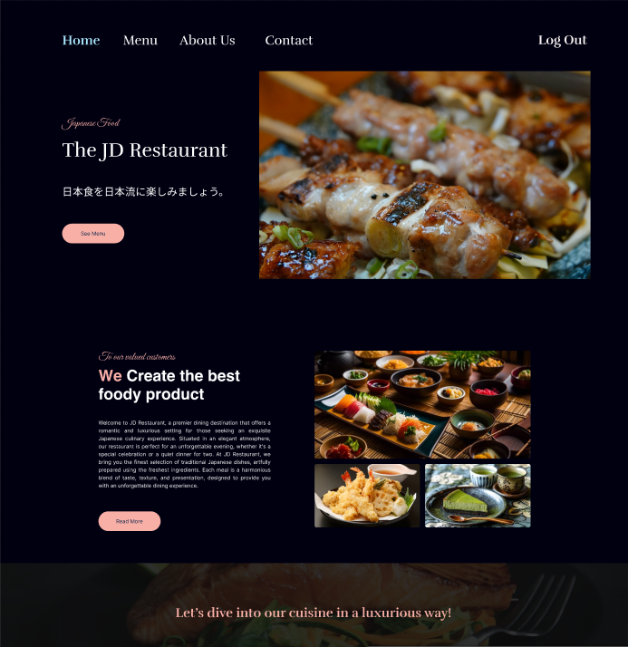

Home Page

The home page serves as the central hub of the website, providing users with an overview of the restaurant’s offerings and key navigation links.

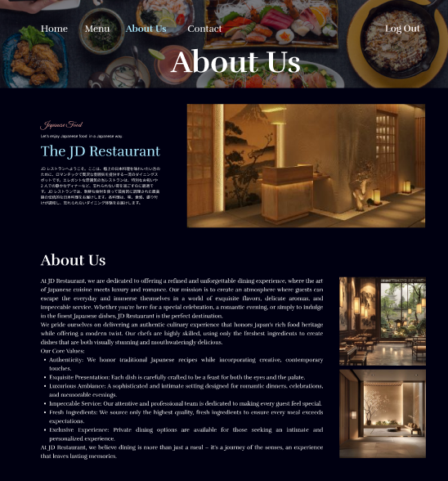

About Us Page

The "About Us" page provides detailed information about the restaurant, its history, and its mission.

* + 1. **Menu Interfaces:**

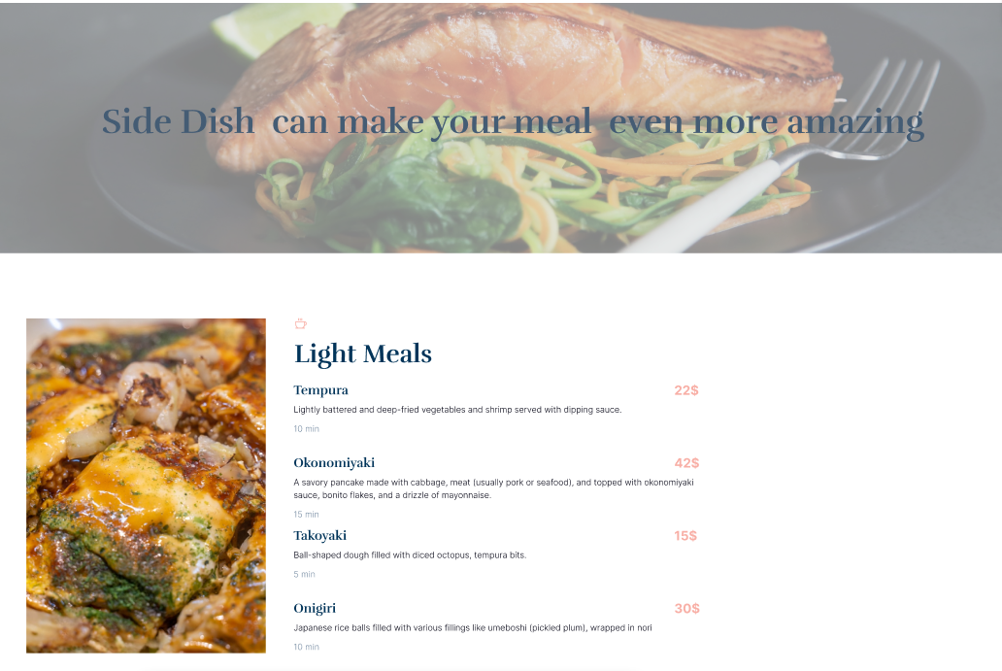

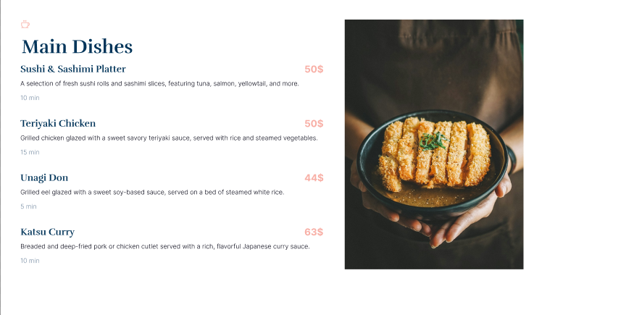

Menu Pages

The menu pages serve as a comprehensive catalog of the restaurant's offerings, allowing customers to browse dishes conveniently. The menu is structured and organized according to food categories to enhance the user experience.

* + 1. **Ordering Interfaces from customer’s side.**

**Step 1: Filling the information of customer.**

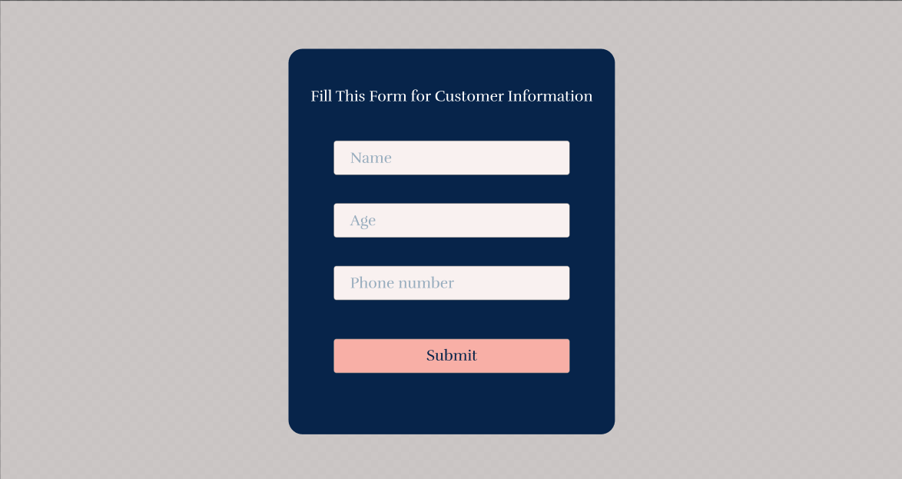

Customer Information Page

The customer information page is designed to collect essential details from users after they log in for the first time. This step ensures that a unique customer ID is created in the database, enabling them to place orders and complete transactions seamlessly.

**Step 2: Choosing the dishes from customer.**

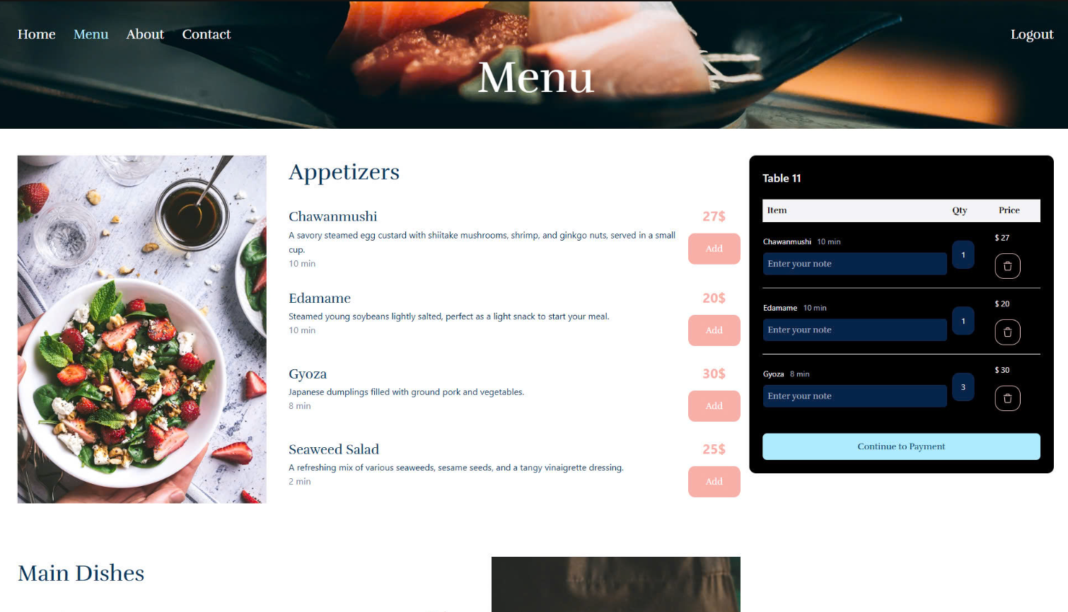

Menu Selection Page

This page allows customers to browse the restaurant's menu, select desired items along with the note for each dish, and proceed to place an order.

* Click "Continue to Payment" → Turn to *Ordering Page.*
* Click "Add" → Add the food into list of requested dishes.
* Click "Bin icon" → Remove the dish from the list.

**Step 3: Ordering the chosen dishes from the customer.**

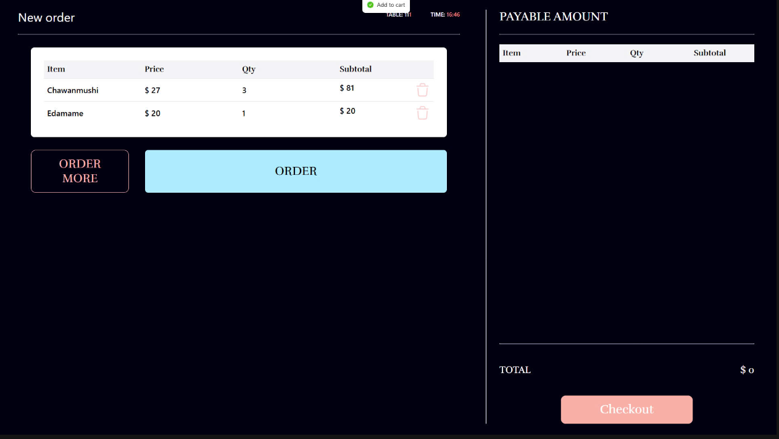

The Ordering Page

This page confirms the customer's selected dishes and allows them to either modify the order or proceed.

* Click "ORDER" → All chosen dishes will be turned to the list of ordered items and sent the order to the admin side.

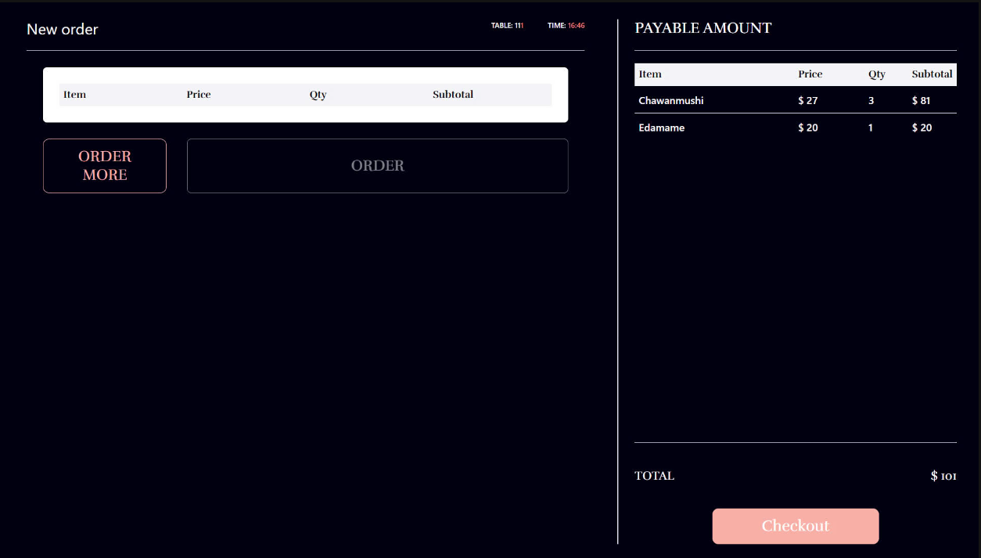

* Click "ORDER MORE" → Return to Menu Selection Page.
* Click "Checkout" → Finish the meal and create the transaction with a bill for that customer and lead the customer to Feedback Page.

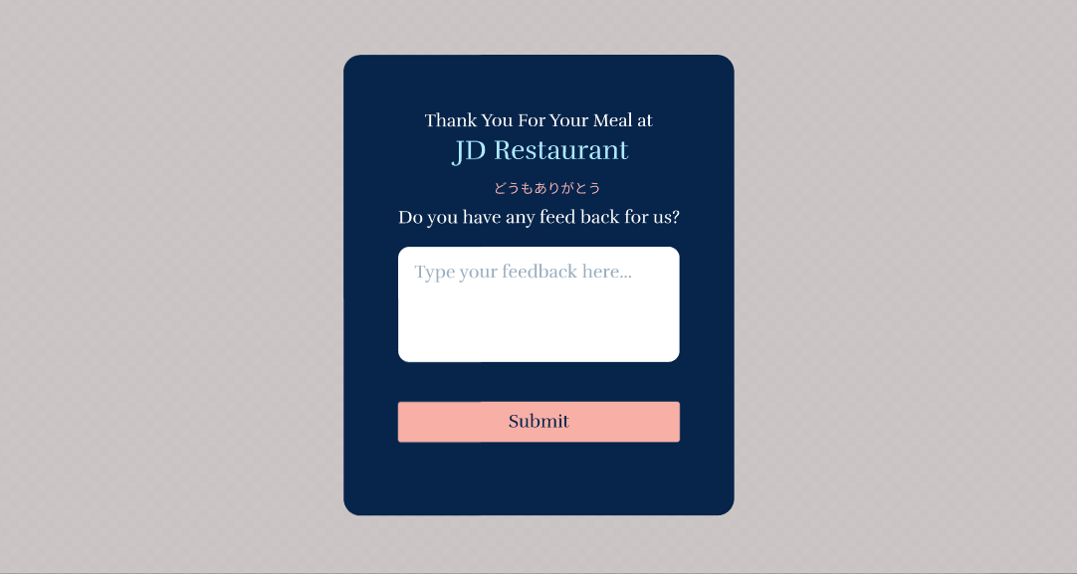

The Feedback Page

This page allows customers to provide feedback along with the transaction about their experience or the specific transaction, helping the admin gather insights to improve services.

**Step 4: Turn to the Menu Selection Page when finishing ordering the dishes.**

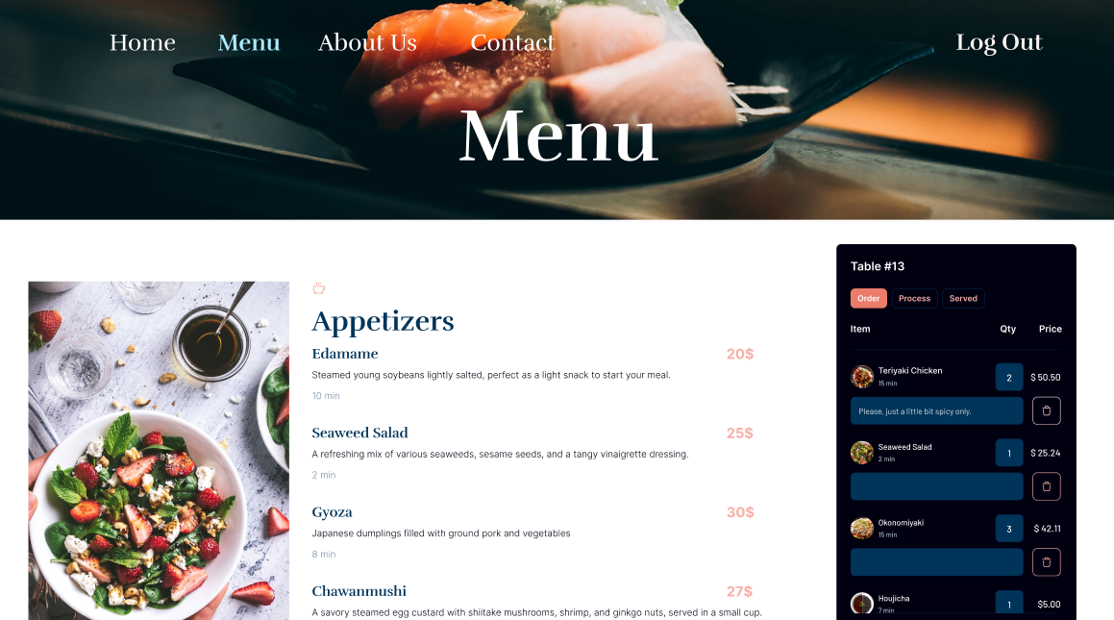

The Menu Page with Order Status

This page provides customers with a detailed view of their ordered dishes and the status of each item, ensuring transparency and real-time updates about the preparation process from the chef’s side.

* 1. **ADMIN ROLE PAGES**
     1. **Menu Page.**

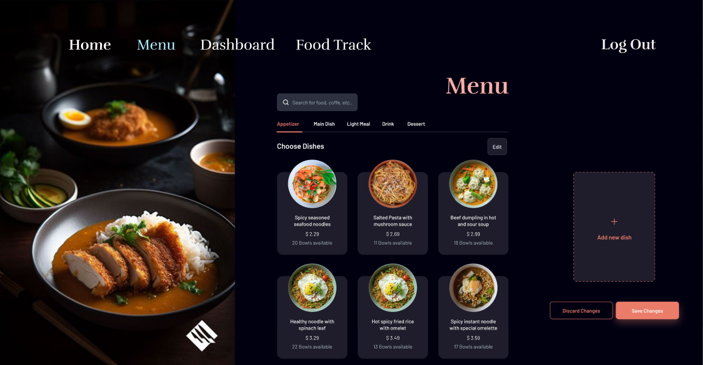

The Menu Page

This page allows the admin to manage the restaurant’s dishes, ensuring the menu is up-to-date and reflective of customer preferences.

* Click "Add new dish" → Create new dishes by entering details.
* Click "Edit" → Edit Existing Dishes including its name, price, or description.
* Click "Save Changes" → Decide to save all current changes.
* Click "Discard Changes" → Decide to discard all current changes.
  + 1. **Dashboard Page.**

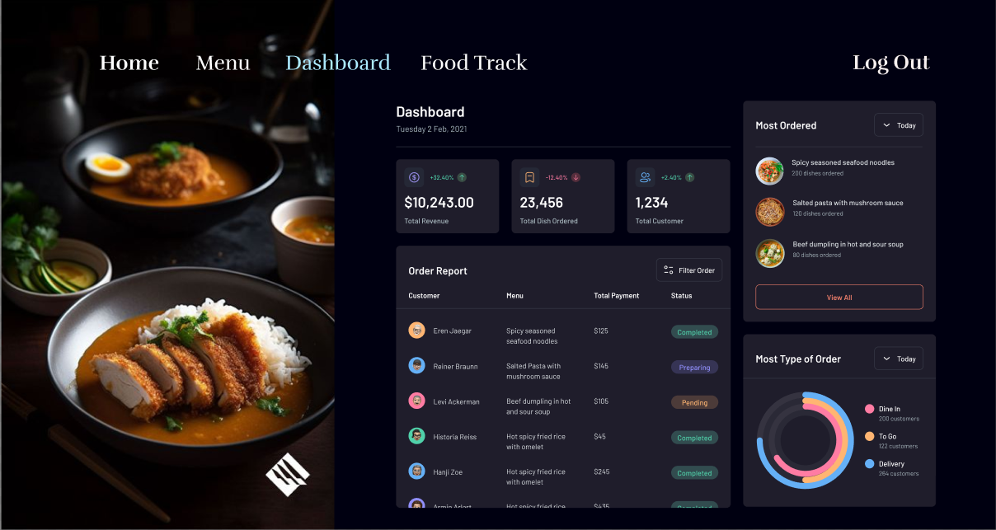

The Dashboard Page

This page provides a comprehensive overview of the restaurant’s performance and transaction data.

* Daily Revenue:
  + Displays the total income generated for the current day.
  + Option to filter revenue by date range for deeper analysis.
* Favorite Dishes:
  + It shows the most popular dishes based on customer orders, ranked by sales.
* Transaction Overview:
  + Displays of all transactions made by customers.
* Transaction Details:
  + View detailed information for each transaction, including list of ordered dishes, quantity and price of each dish, …
    1. **Food Track Page.**

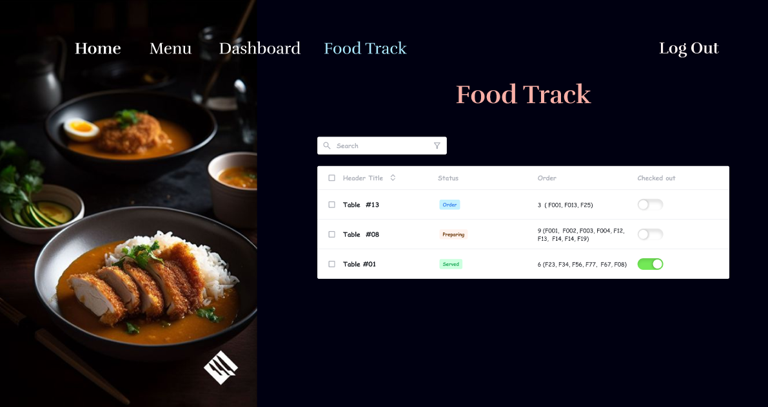

The Food Track Page

This page allows the admin to monitor and manage the status of orders from ongoing tables, ensuring efficient service.

* View all ongoing tables and their respective orders, including:
  + Table Number or ID.
  + List of dishes ordered per table.
  + Status of each dish.
* Change the status of any dish in real-time, with options:
  + Order: The order is received but not yet prepared.
  + Process: The dish is being cooked.
  + Served: The dish has been delivered to the customer.
* Reflect changes immediately on the customers’ side to keep them informed.

# DISCUSSION AND CONCLUSION

The project of Smart Restaurant Management System provides valuable insights into the process of web application development and real-time system integration. As the project concludes, there are several areas for future improvement and extensions. Firstly, to enhance customer experience, the system could incorporate a more personalized approach by integrating customer preferences, such as recommending popular dishes or frequently ordered items based on past orders. This would increase customer satisfaction and boost the restaurant's efficiency. Secondly, the system could be extended to include real-time analytics for the manager, providing insights into daily trends, peak hours, and popular menu items. Lastly, for wider deployment beyond a demo environment, ensuring scalability and seamless integration with third-party payment systems is crucial to provide a smooth and secure transaction experience for customers.

Through this project, we also gained significant learning and skill development. Firstly, we enhanced our technical abilities in implementing features such as secure online ordering, real-time communication between kitchen and customer, and payment verification processes. These are key components of a functional and scalable system. Secondly, our skills in requirement analysis were sharpened, as we translated Steve's vision into a practical and efficient implementation plan. Finally, working on a project of this scale improved our teamwork and communication skills, enabling effective collaboration, task allocation, and conflict resolution within the team.

In summary, the Smart Restaurant Management System project has been a valuable opportunity to apply theoretical knowledge to practical challenges. It has allowed us to strengthen our technical expertise, refine our analytical thinking, and develop essential professional skills that will benefit us in future projects.

# REFERENCES

* **SCRUM**
  + https:[//www.scrum.org/](http://www.scrum.org/)
* **Agile**
  + <http://agilemethodology.org/>
* **Web-page template**
  + <http://themeforest.net/>
* **Database Management System (DBMS)**
  + <http://www.oracle.com/>
* **HTML, CSS, JavaScript techniques**
  + [www.w3schools.com](http://www.w3schools.com/)
* **Text data and image data**
  + [www.nguyenhoanggiang.com](http://www.dogokhanhchung.com/)
* **Java mailing component applications**
  + [www.oracle.com/technetwork/java/javamail/index.html](http://www.oracle.com/technetwork/java/javamail/index.html)